It Never Rains In Southern California (Accompaniment)

G 2 3 4 Am 2 3 4 D 2 3 4 G 2 3 4 G

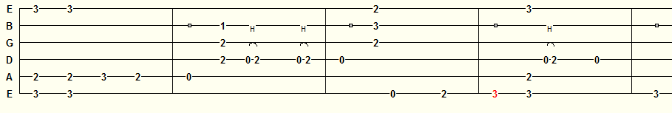

Lyin’ Eyes (Accompaniment)
G 2 3 4 Gmaj7 2 3 4 C 2 3 4 Am 2 3 4 D 2 3 4 G 2 3 4 G
