Picking Practice (with plectrum)

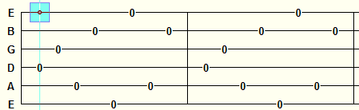

4th 3rd 5th 2nd 6th 1st 5th 2nd 4th 3rd 5th 2nd 6th 1st 5th 2nd

Picking Practice (with D String)

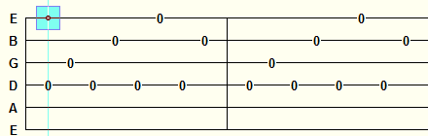
4th 3rd 4th 2nd 4th 1st 4th 2nd 4th 3rd 4th 2nd 4th 1st 4th 2nd

Picking Practice (with A String)

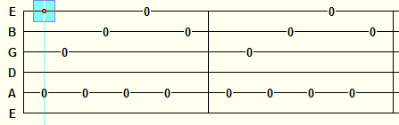
5th 3rd 5th 2nd 5th 1st 5th 2nd 5th 3rd 5th 2nd 5th 1st 5th 2nd

Picking Practice (with E String)

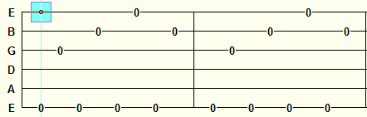
6th 3rd 6th 2nd 6th 1st 6th 2nd 6th 3rd 6th 2nd 6th 1st 6th 2nd

